SUPPORT VECTOR CLASSIFICATION

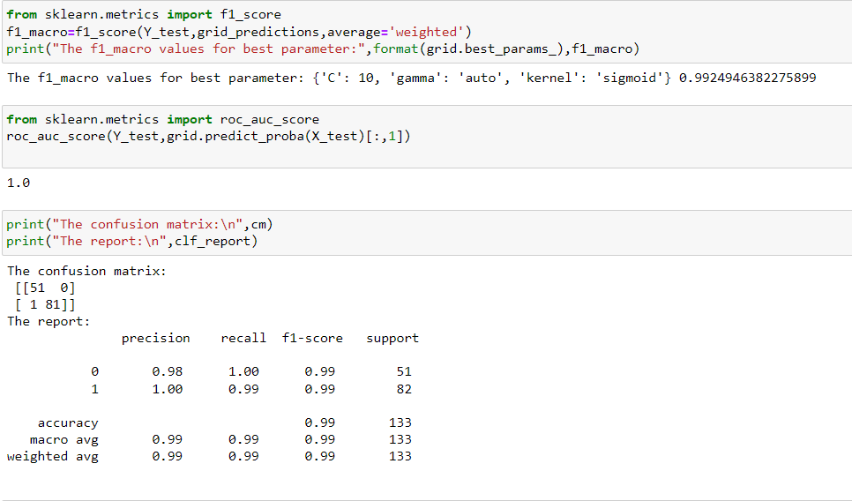

**The best parameter= kernel:sigmoid, gamma:auto, C=10**

**Roc value=1.00**

**F1_weighted value =0.99**

DECISION TREE CLASSIFICATION

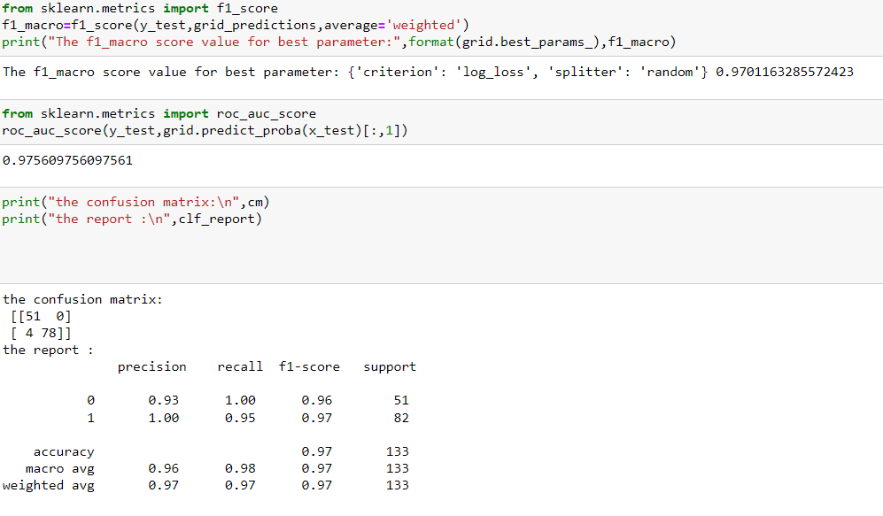

**The best parameter= criterion:random, splitter: log_loss**

**Roc value=0.97**

**F1_weighted value=0.97**

RANDOM FOREST CLASSIFICATION

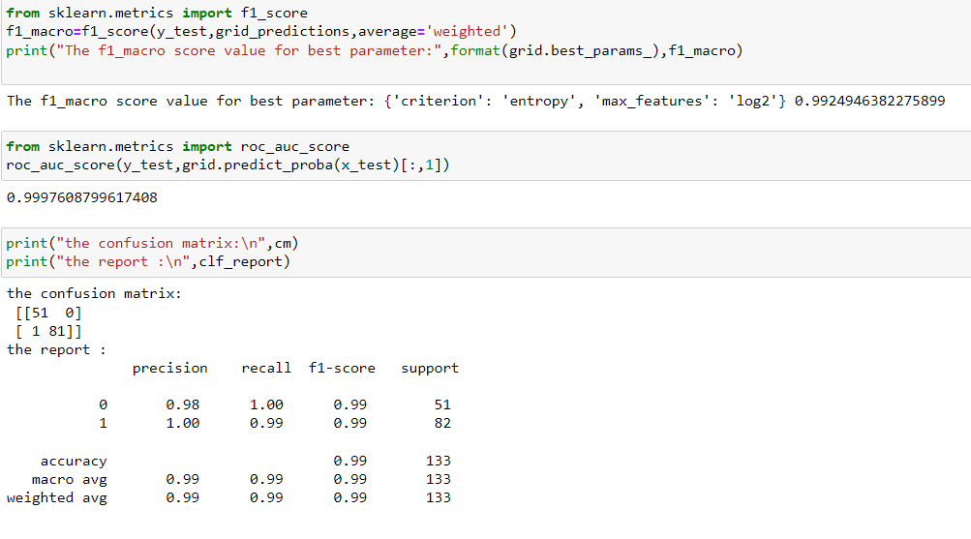

**The best parameter= criterion: entropy, max_features: log2**

**Roc value=0.99**

**F1_weighted value=0.99**